Custom Training

Day 14

**Python**

Function: We can create a utility notebooks for data processing.

Function Composition: Call one function inside another function.

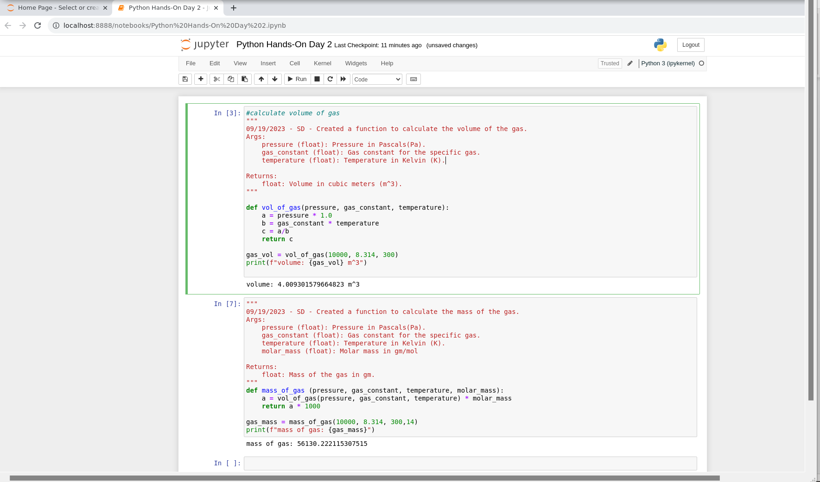

Recursive Function: To call a function repetitively inside the same function until base condition is met.

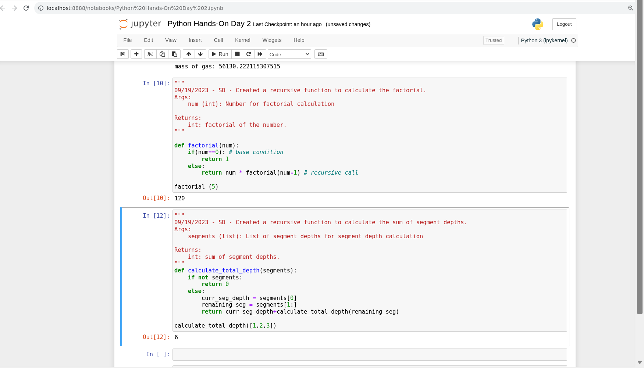

Generator Function: It saves the current state of the function by using the keyword yield instead of return.

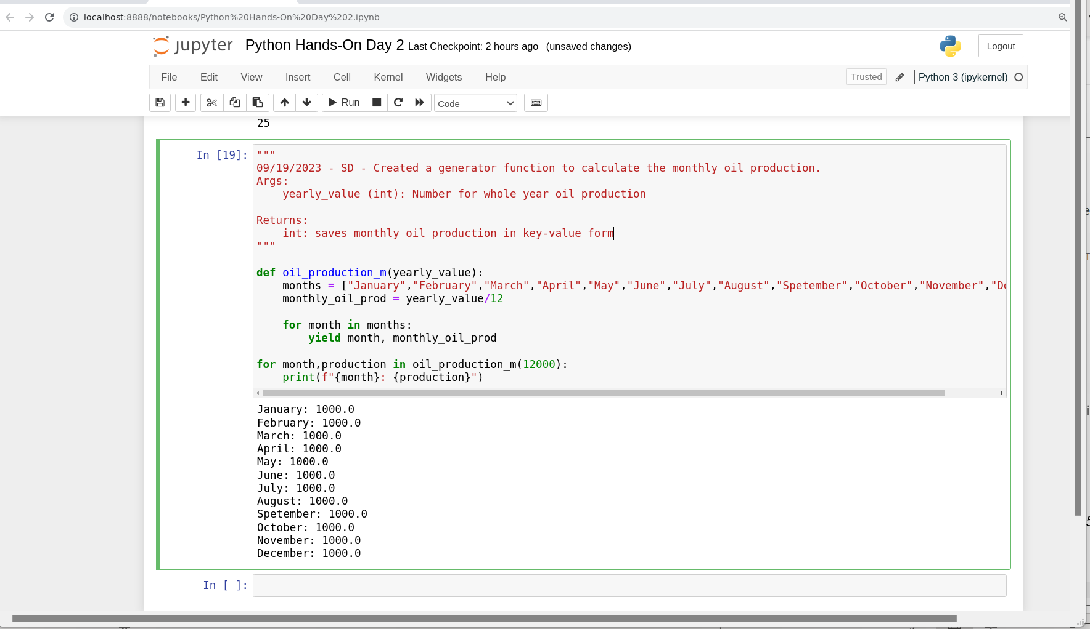

Decorator Function: Primarily used for logging activities.

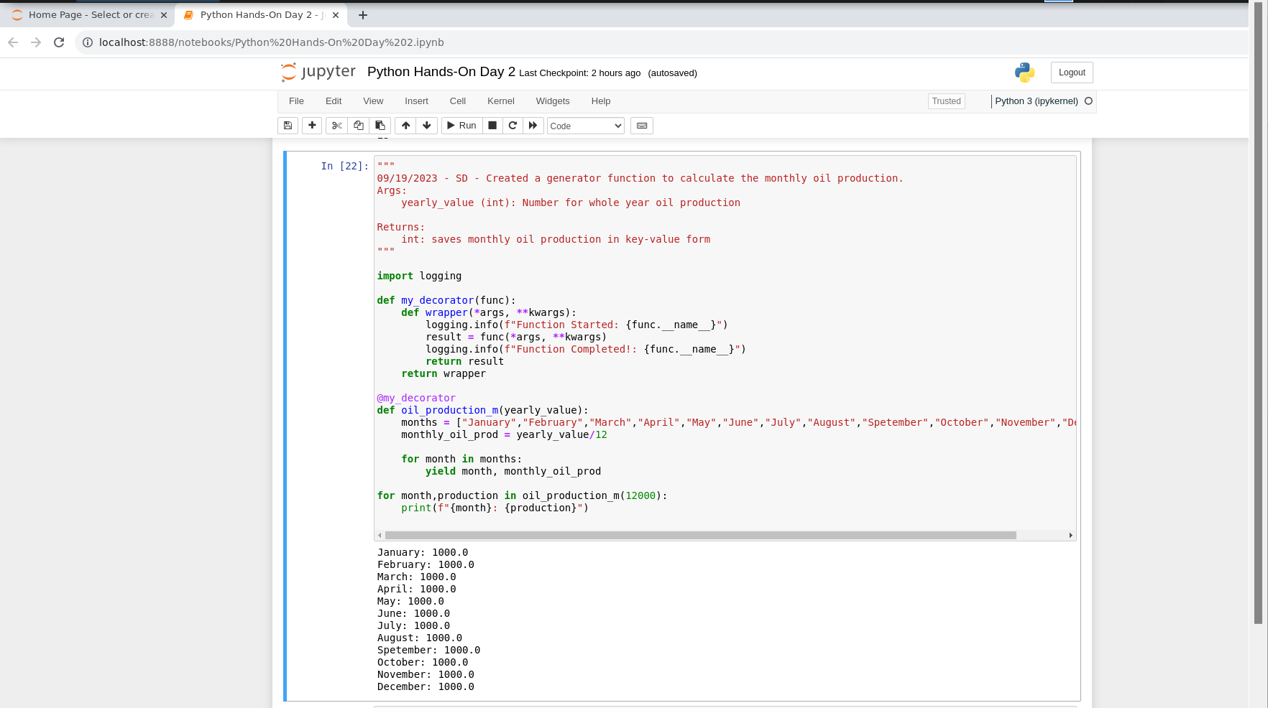

Positional Arguments: When we simply pass the arguments while calling the function without specifying the parameter name.

Keyword Arguments: When we explicitly mention the parameter names while passing the arguments in function calling.

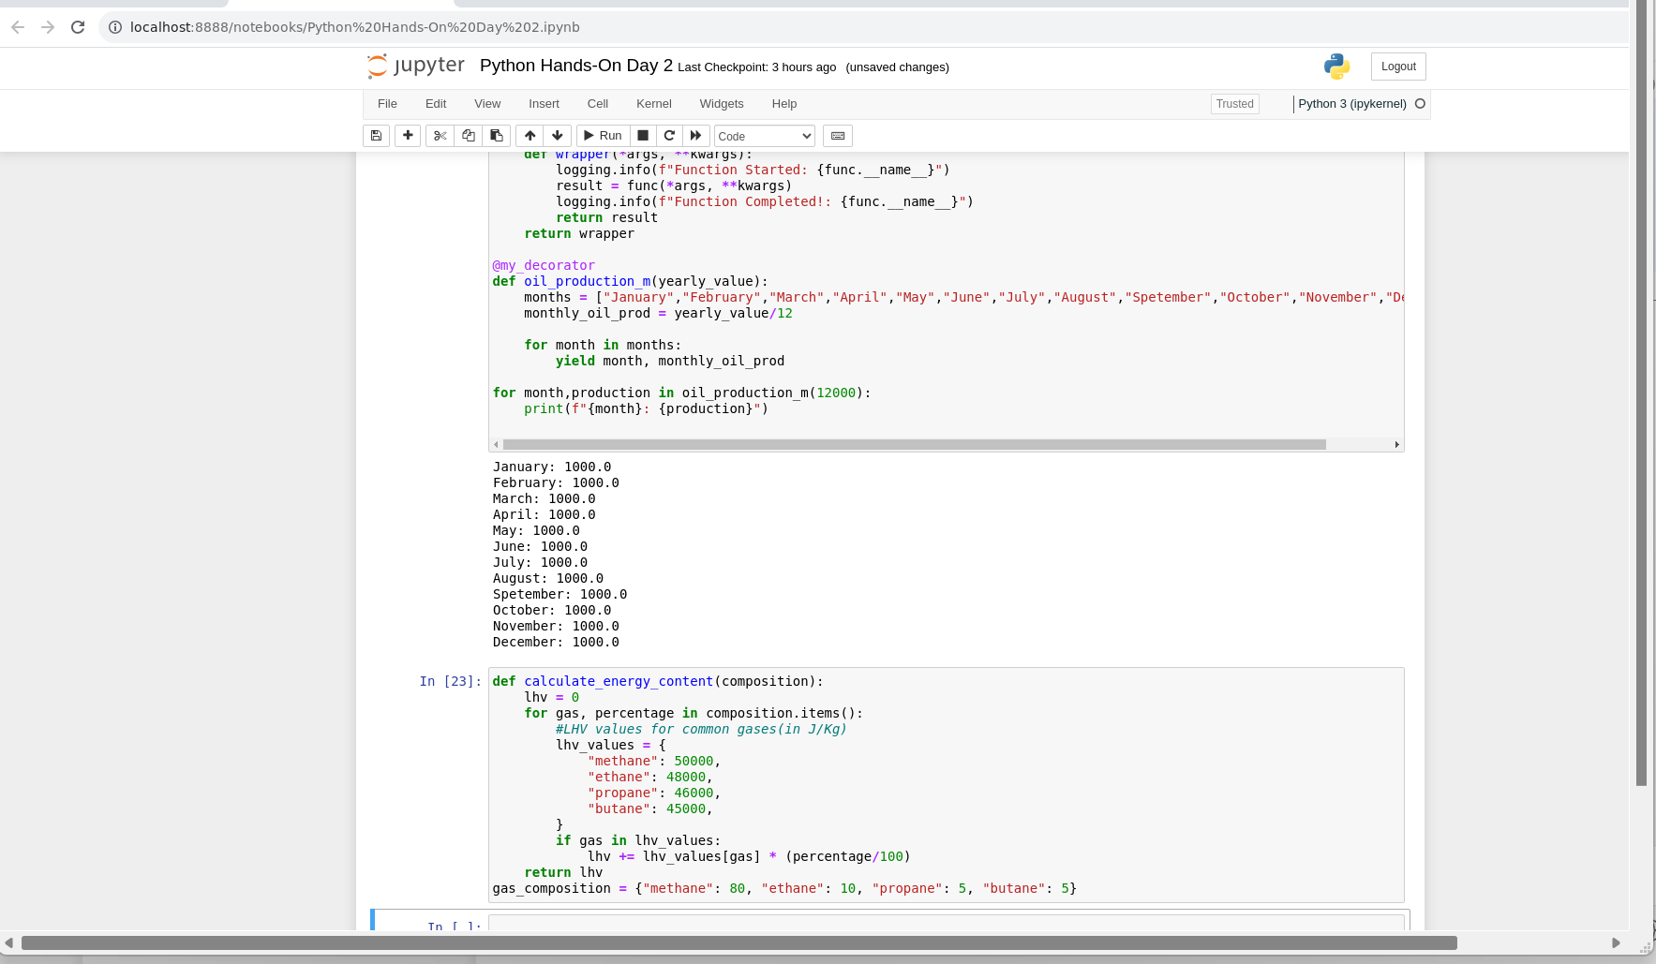

Class: Logical grouping of functions and fields.

Global Variable: Class level field.

Local Variable: Function level field.

Constructor: Used to initialize the class fields.

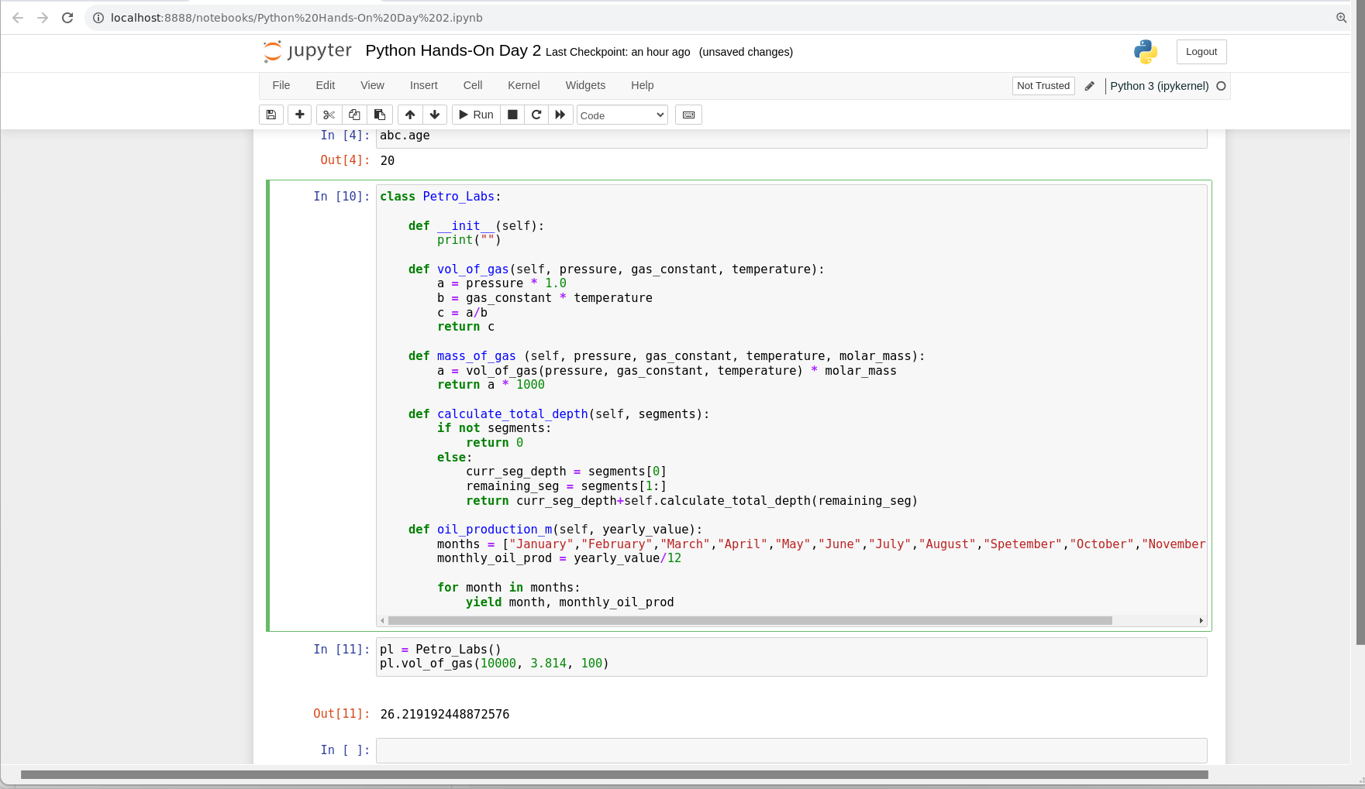

Timestamps:

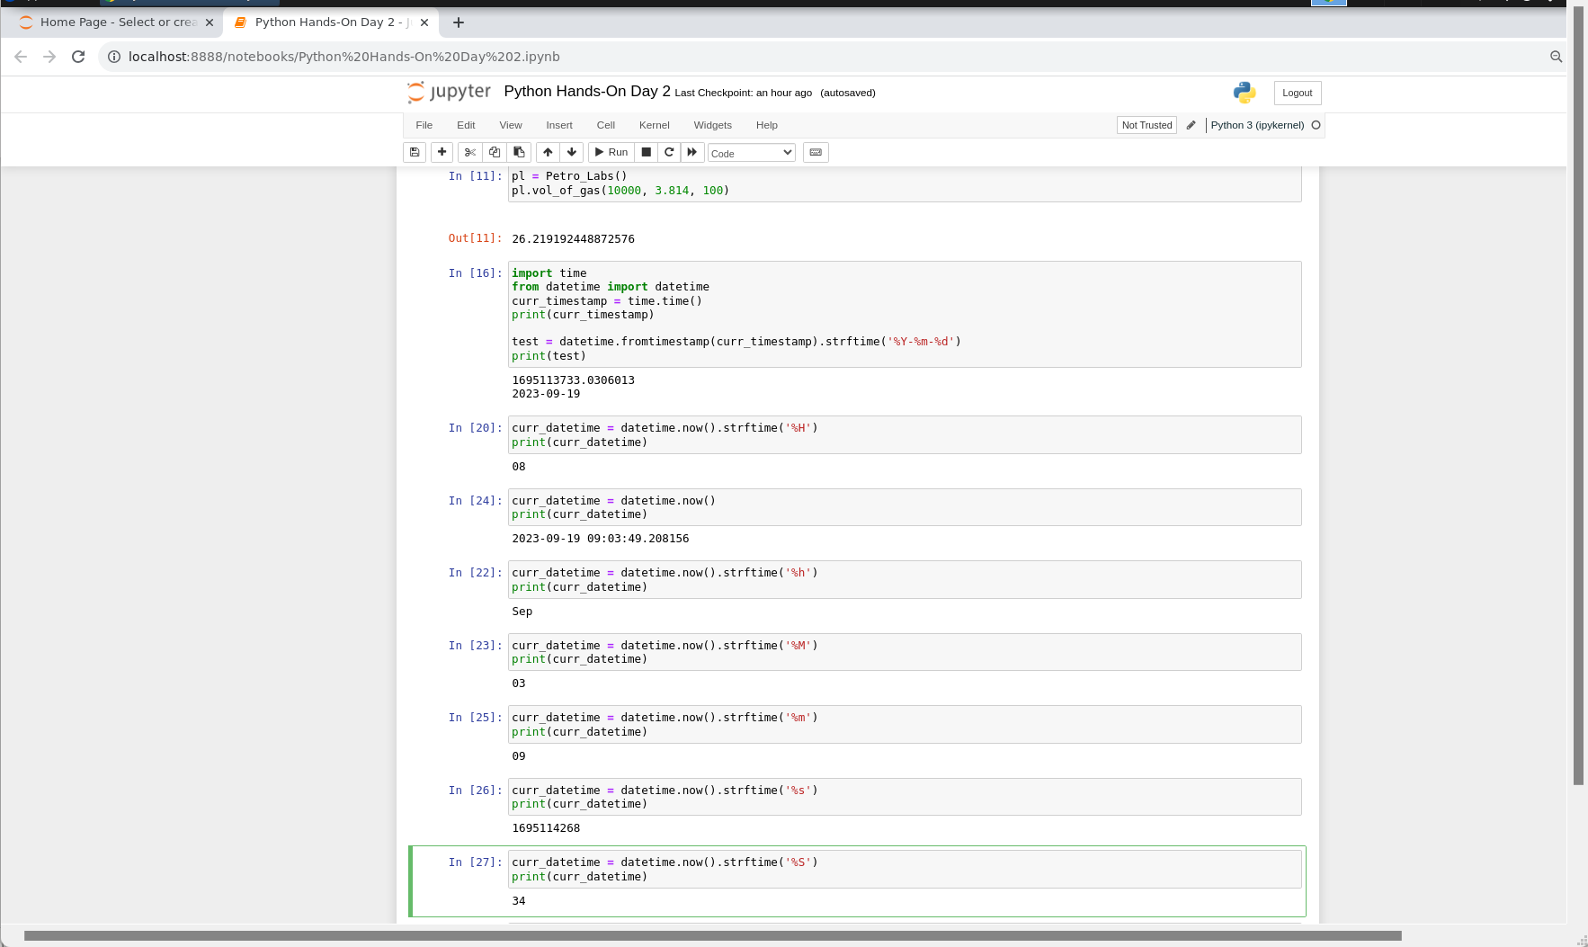

Exception Handling: To handle unexpected or exceptional cases/events.

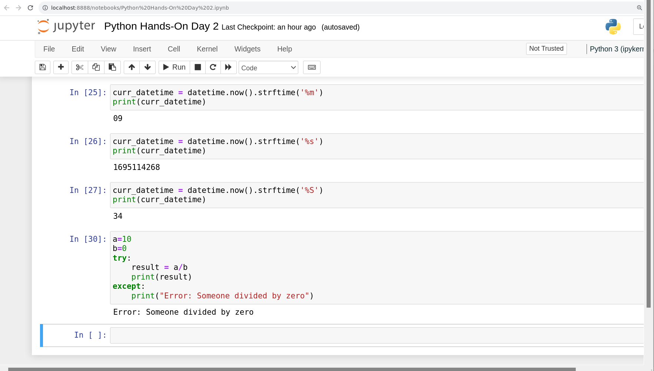

List Comprehension: To write 2-3 lines of code of for and if into one line of code.

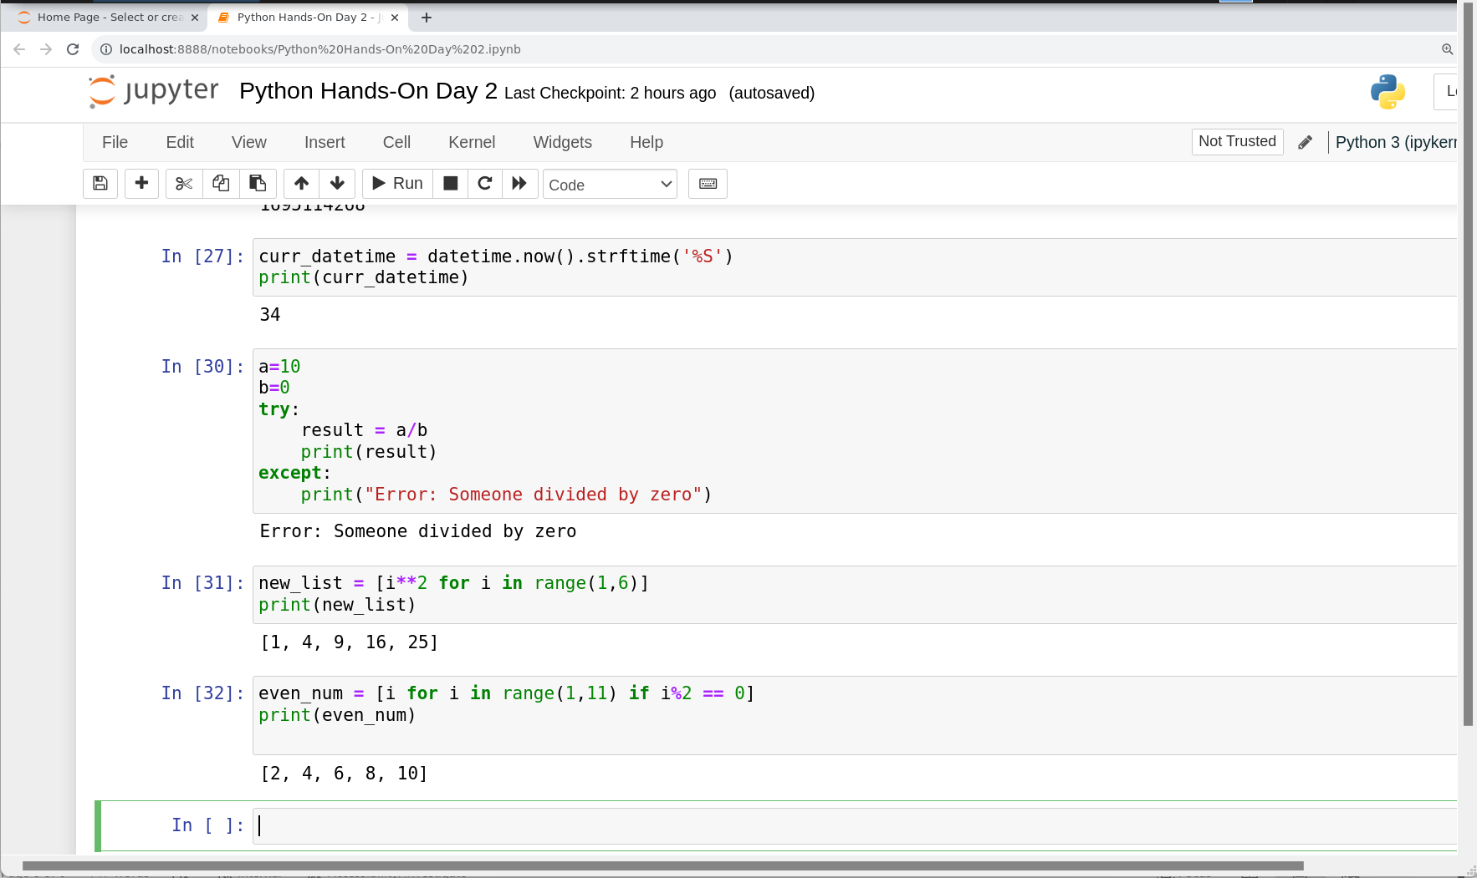

Lambda Function: Anonymous function.

